Handout no. 2

|  |  |
| --- | --- |
| **Name** | Ahmad Bandesha, Faizan Azam, Muhammad Asad |
| **Reg. No** | 2019-EE-373, 2019-EE-381, 2019-EE-383 |
| **Marks/Grade** |  |

**EXPERIMENT # 2**

**Implementation of Gauss-Siedle Method in multivariable system**

**Objectives:**

At the end of this lab session students will be able to

* To design Power system operations in in Power World Simulator.
* To observe power flow in power System.

**Introduction:**

Load flow analysis is the study conducted to determine the steady state operating condition of the given power system under given conditions. Many numerical algorithms have been developed and Gauss Seidel method is one of such algorithms. The Gauss–Seidel method is also a point-wise iteration method and bears a strong resemblance to the Jacobi method, but with one notable exception. In the Gauss–Seidel method, instead of always using previous iteration values for all terms of the right-hand side, whenever an updated value becomes available, it is immediately used. The non-linear load flow equation is given by:





The gauss-seidel method is an iterative algorithm for solving a set of nonlinear load flow equations. The process of computing all the bus voltages is called one iteration. the iterative process is then repeated till the bus voltage converges with in prescribed accuracy.

Gauss-Seidel (G-S) method is one of the simplest iterate method. It is a modification of Gauss-Iterative method. This modification will reduce the numbers of iterations. So, it is suitable for the power flow study of small power system.

Gauss-Seidel Method is used to solve the linear system Equations. This method is named after the German Scientist Carl Friedrich Gauss and Philipp Ludwig Seidel. It is a method of iteration for solving n linear equation with the unknown variables.

The reason the Gauss–Seidel method is commonly known as the successive displacement method is because the second unknown is determined from the first unknown in the current iteration, the third unknown is determined from the first and second unknowns, etc.

**Advantages**

* Gauss Seidel method is easy to program.
* Each iteration is relatively fast (computational order is proportional to number of branches and number of buses in the system).
* Acquires less memory space than NR method.



**Figure 2.1: Power System to Analyze**

The figure shown above is the one-line diagram of a simple three-bus power system with generation at buses 1 and 3.the voltages at bus 1 is V1=1.025 ∠0 ° pu. Voltages magnitude at bus 3 is fixed at 1.03pu with a real power generation of 300MW.A load consisting of 400MW and 200MVar is taken from bus 2. Line impedances are marked in per unit on a 100-MVA base.

* Using Gauss Seidel method and initial estimate of V2(0) =1+0j and V3(0) =1.03+0j and keeping |V3|=1.03 pu, determine the phasor values of V2 and V3. Perform three iterations. (Hand Calculation)
* Also simulate the above circuit in power World Simulator and match your hand calculations with the result obtained from PWS.

**Using PWS**

* Draw the one-line diagram in PWS.
* In the Run Mode, go to Tools Solve Gauss Seidel Power Flow. This will give you the result of the bus voltages after performing all iterations.
* To check your results iteration, go to Tools Simulator Option Common Option Check ‘Do Only for One Iteration’. Now repeat the above step to get results for each iteration.
* While doing single iteration you will hear warning sound until the solution converges
* The detailed result of each iteration can be viewed through log in the Tools selection.
* **Task #01:**

Use Guass-Siedel method to find the solution of following equations

+=6

Perform five iterations with following initial estimates

a) =1 and b) =2

**Mathematical Calculation:**

------ (l)

= 101+ -------(a)

+=6 ----------- (ll)

= 6-------------(b)

By using Initial estimate in equation (a) and (b)

**1st iteration:**

= 101+2 = 103 = 3.33

= 6-3.33 = 2.67

**2nd iteration:**

= 101+2.67 = 103.67 = 2.72

= 6-2.72 = 3.27

**3rd iteration:**

= 101+3.27 = 104.27 = 2.34

= 6-2.34 = 3.65

**4th Iteration:**

= 101+3.65=104.65 =2.15

= 6-2.15 = 3.84

* **Task 2:**

**Guass-Siedel Power Flow Simulation**

* **Software Simulation:**

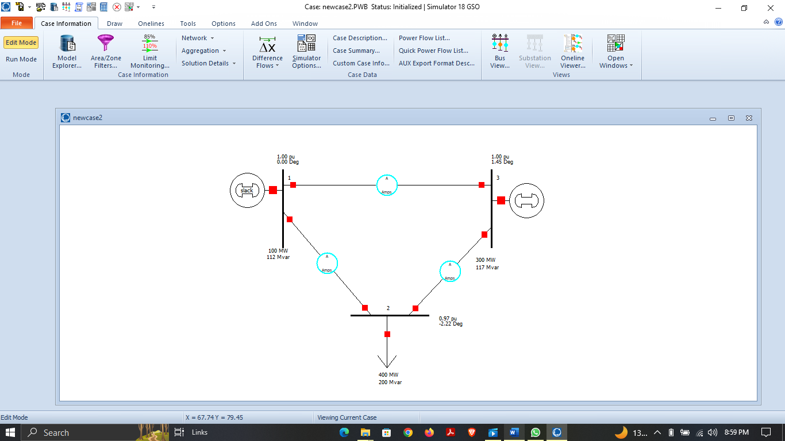

**Figure 2.2: Three Bus Power System in Edit Mode**

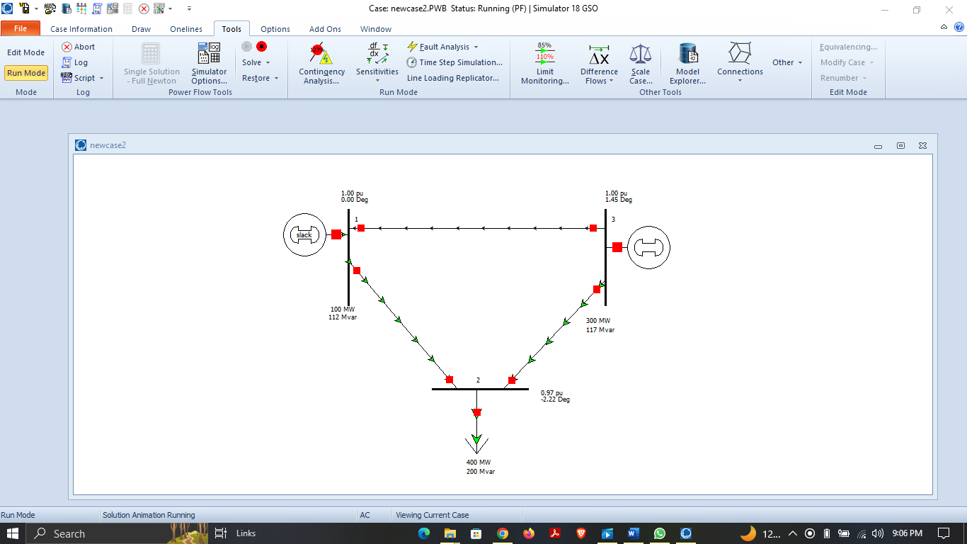

**Figure 2.3: Three Bus Power System in Run Mode**



**Figure 2.4: Y-Bus Matrix**

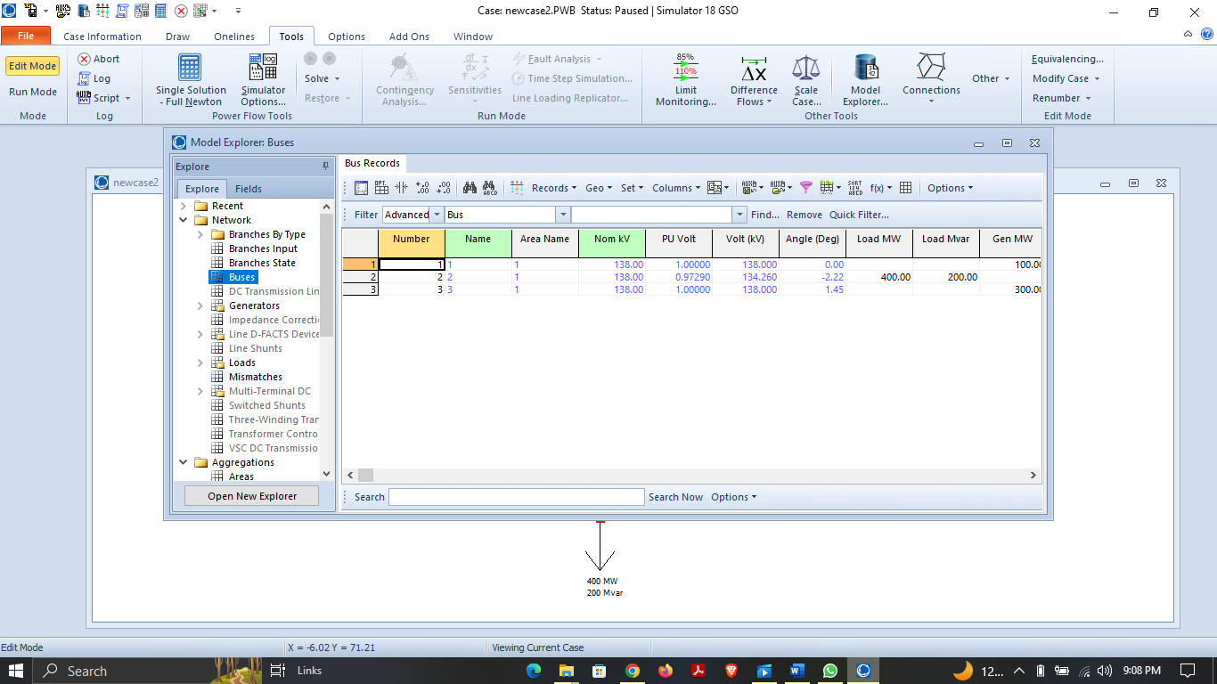

**Figure 2.5: Characteristics of three bus power system network**

* **Theoretical Calculation:**

𝒀 𝒃𝒖𝒔 =

R= 0Ω

X = j0.05 (from bus 1 to bus 3)

X = j0.025 (from bus 1 to bus 2 and bus 2 to bus 3)

Y = 1𝑅+𝑗𝑋

Y12 = -Y21 = 1𝑗0.025 = -40j

Y13 = -Y31 = 1𝑗0.05 = -20j

Y23 = -Y32 = 1𝑗0.025 = -40j

Y11 = Y12 + Y13= -40j – 20j = -60j

Y22 = Y21 + Y23= -40j – 40j = -80j

Y33 = Y31 + Y32= -20j – 40j = -60j

By putting all values in above Ybus matrix

𝒀 𝒃𝒖𝒔 =

* **Mathematical Calculations:**

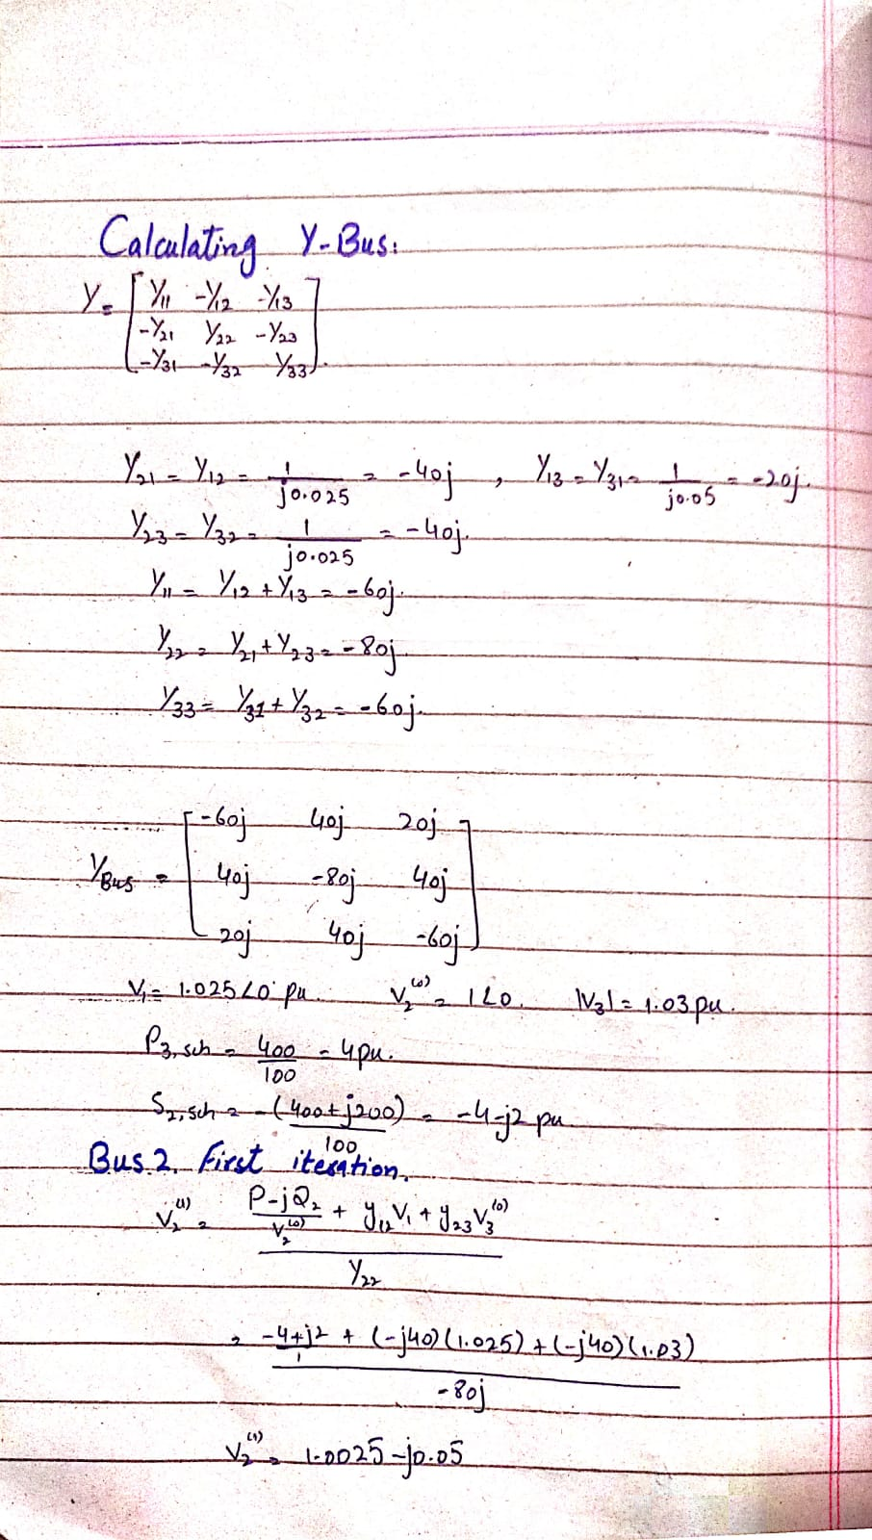

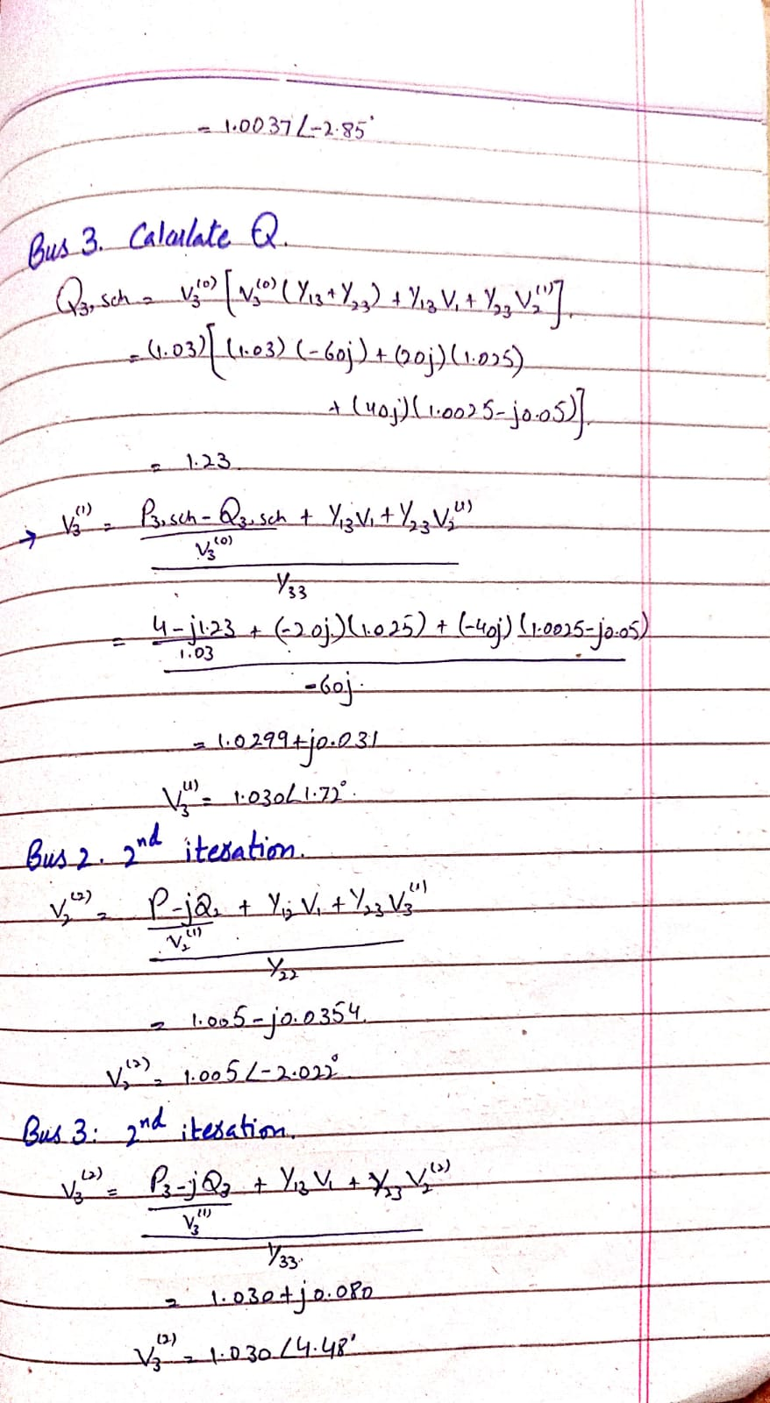

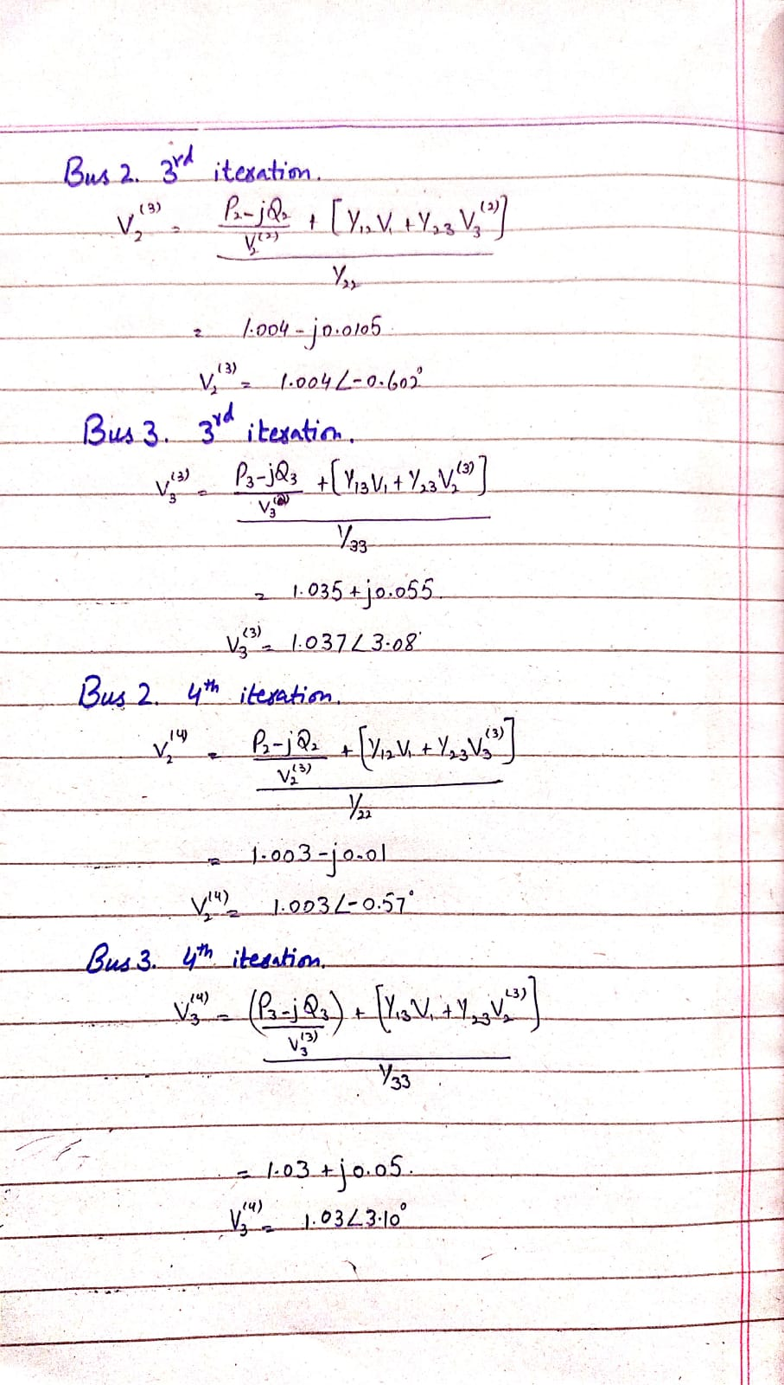

* **Comparison Table:**

|  |  |  |  |  |  |
| --- | --- | --- | --- | --- | --- |
| **Bus Voltages** | **Calculations** | | **PWS** | |  |
| **Voltages (pu)** | **Angle** | **Voltages (pu)** | **Angle** |
| 1st Iteration | 1.0037 | -2.85 | 0.96 | -2.6 |
| 2nd Iteration | 1.005 | -2.002 | 0.97 | -2.22 |

**Table 2.1: For Bus 2**

|  |  |  |  |  |
| --- | --- | --- | --- | --- |
| **Bus Voltages** | **Calculations** | | **PWS** | |
| **Voltages (pu)** | **Angle** | **Voltages (pu)** | **Angle** |
| 1st Iteration | 1.096 | 0.78 | 0.98 | 1.17 |
| 2nd Iteration | 1.030 | 1.21 | 1 | 1.45 |

**Table 2.2: For Bus 3**

* **Comments & Observations:**

Gauss-seidel method is more reliable and results are accurate, require a smaller number of iterations but program is more complex, memory is more complex. Gauss–Seidel method is commonly known as the successive displacement method is because the second unknown is determined from the first unknown in the current iteration, the third unknown is determined from the first and second unknowns, etc. Gauss-seidel method is more efficient than Jacobi method as gauss-seidel method requires a smaller number of iterations to converge to the actual solution with a certain degree of accuracy.